RAPID MAXILLARY EXPANDER

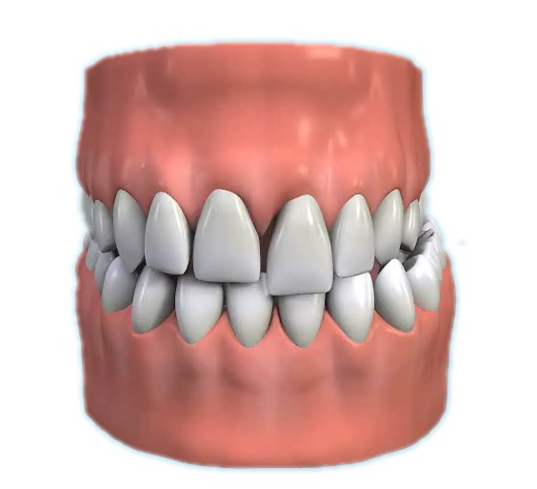

Q What is a crossbite?

A A crossbite is when the teeth come together but either inside or totally outside their correct positions. The most common crossbite occurs when the top back teeth are inside the lowers usually on one side only.

Q How can a crossbite be rectified?

A In the most common occurring crossbite, the upper tooth arch can be widened.

Q What is a Rapid Maxillary Expander?

A A Rapid Maxillary Expander is a brace which is fixed to the upper teeth. It has a screw in the middle of the palate.

Q How does the Rapid Maxillary Expander work?

A The screw in the middle of the brace is turned twice daily for two weeks. This very quickly expands the upper jaw.

Q Will it hurt?

A There is some discomfort for the first two or three days. This can be controlled with paracetamol or your preferred pain relief.

Q How long will the Rapid Maxillary Expander need to be in place?

A The Rapid Maxillary Expander will need to be worn for a minimum of three months.

Q Will there be any permanent damage?

A The fixed brace expander is not in place long enough to cause any damage. It will be replaced with a removable retainer after 12 weeks.

Poor cleaning and too many fizzy drinks, however, can cause permanent decay marks around the fixings. The importance of thorough brushing and the use of a fluoride mouthwash cannot be emphasised enough.

Q Is the treatment permanent, or will I need additional future treatment?

A The correct use of the removable retainer for 12 months after the Rapid Maxillary Expander has been replaced will usually ensure the improvement is permanent.

